NASM Odour Guide

For Ontario Regulation 267/03
Made under the Nutrient Management Act, 2002

July 25, 2012

Ministry of the Environment
Ministry of Agriculture, Food and Rural Affairs
Table of Contents

1.0 DEFINITIONS ……………….3

2.0 INTRODUCTION 5

3.0 PURPOSE 5

4.0 ODOUR Categories 5
4.1 Basic Method: NASM Odour Category Table
4.2 Procedure to Assign or Reassess and Assign NASM Odour Category (Director’s Assignment)
4.3 Odour Assessment Test

5.0 BASIC METHOD: NASM ODOUR Category TABLE 7

6.0 Procedure to Assign or Reassess and Assign NASM Odour Category (Director’s Assignment) ………………………………………….…. 7

6.1 Procedures To Assign NASM To An Odour Category
6.2 Procedures To Reassess And Assign NASM To An Odour Category

7.0 NASM SAMPLING For ODOUR ASSESSMENT …. 8
7.1 Sampling Liquid NASM
7.2 Sampling Solid NASM

8.0 ODOUR ASSESSMENT………………………………………………………….……. 9
8.1 Laboratory Sampling Method
8.2 In-Field Sampling Method
8.3 Area Source EPA Style Flux Chamber Sampling Procedure
8.3.1 Apparatus
8.3.2 Preparation
8.3.3 Sampling Procedure
8.3.4 Sample Recovery
8.4 Sample Evaluation / Odour Detection Threshold Determination
8.4.1 Dilution Apparatus
8.4.2 Odour Evaluation Panel
8.4.3 Odour Evaluation and Calculation of Odour Concentration

9.0 REFERENCES 17

1.0 DEFINITIONS

For the purpose of this Guide, the following definitions apply:

“anaerobic digestion output”, as defined in O. Reg. 267/03, means any solid or liquid material that results from the treatment of anaerobic digestion materials in a mixed anaerobic digestion facility;

“certified NASM plan developer” means a person responsible for preparing the NASM plan, who holds a NASM Plan Development certificate issued under Section 102 of O.Reg 267/03

“commercial, community or institutional use” as defined in O. Reg. 267/03 means any commercial, community or institutional use, including without limitation the use of land for,

- an office building,
- a hotel, motel, hostel or similar type of accommodation,
- an overnight camp or overnight campgrounds,
- indoor recreational or sporting activities,
- indoor gatherings for civic, religious or social purposes,
- indoor performing arts activities,
- a railway station, airport passenger terminal or other embarkation or debarkation point for travelers,
- a day care centre,
- educational purposes, including a school, college, university, private career college or associated residence,
- a health care facility,
- a penitentiary, jail or other place of custody or detention.

“Director”, as defined in the Nutrient Management Act, 2002, means a Director appointed under subsection 3 (1) of the Act;

“DT” in reference to a sample, means, the dilution factor at which the sample has a 50% probability of being detected by an odour panel under the conditions of the odour assessment test as detailed in this guide.

“dwelling”, as defined in O. Reg. 267/03, means a structure that is used as a residence, including a mobile home or a seasonal home, but not including a structure that is in a residential area;

“guide” means this document;

“NASM plan”, as defined in O.Reg. 267/03, means a nutrient management plan for the management of NASM and other nutrients that may be applied to NASM application areas or stored in NASM storage facilities;

“neutral gas” means air or nitrogen that is treated in such a way that it is as odourless as technically possible and that does not, according to panel members, interfere with the odour under investigation;

“non-agricultural source material” or “NASM”, as defined in O. Reg. 267/03

“nutrient management plan”, as defined in the Nutrient Management Act, 2002, means a plan for the management of materials containing nutrients that may be applied to lands, which plan is prepared in accordance with the regulations;

“Nutrient Management Tables” means the document of that name, as amended from time to time, prepared by the Ministry of Agriculture, Food and Rural Affairs and the Ministry of the Environment for the purposes of the NASM Odour Guide and the Nutrient Management Protocol

“odour detection threshold” means the dilution ratio at which a sample has a 50% probability of being detected by an odour evaluation panel;
“odour evaluation panel” means a panel of a minimum of 6 odour evaluation panel members;
“odour evaluation panel member” means an assessor who is qualified to judge samples of odourous gas, using dynamic olfactometry within the scope of European Standard EN 13725:2003;
“odour unit (OU)” One odour unit is the amount of odourant(s) present in one cubic meter of neutral gas (measurements are room temperature (20⁰C) and normal atmospheric pressure (101.3 kPa) calculated on a wet weight basis) at the odour detection threshold determined by the odour evaluation panel and for the purposes of this Guide are the equivalent of one European Odour Unit;
“pulp and paper biosolids”, as defined in O. Reg. 267/03, means solid or liquid material that results from the treatment of wastewater generated by a manufacturer of pulp, paper, recycled paper or paper products including corrugated cardboard;
“residential area”, as defined in O. Reg. 267/03, means an area in which there are four or more lots of not more than one hectare,
(a) that are adjacent to each other or not separated by anything other than a road allowance or right of way, and
(b) on each of which there is a residential building;

“sewage biosolids”, as defined in O. Reg. 267/03, means the residue from a sewage treatment works following treatment of sewage and removal of effluent;

2.0 INTRODUCTION

O. Reg. 267/03, the “General” regulation made under the Nutrient Management Act, 2002, sets out an odour classification system for non-agricultural source materials (NASM) that are applied to agricultural land. This guide sets out the 3 methods that can be used to determine where a specific NASM fits within the odour classification system including historical data, comparative and empirical assessment and the professional judgment of ministry staff. The regulation prescribes setback distances from dwellings, residential areas and land with a commercial, community or institutional use based on odour categories and application method. The odour category also affects storage and handling requirements for OC3 NASM.

3.0 PURPOSE

This guide is intended to provide the regulated community, e.g., generators, haulers, and receivers of NASM, with direction in determining the odour category so that the correct regulatory requirements can be identified related to the NASM that they are land applying. This guide will also be considered by Ministry of the Environment (MOE) and Ministry of Agriculture, Food and Rural Affairs (OMAFRA) staff as part of the review process for nutrient management plans involving NASM, NASM plans and other enforcement/ implementation activities.

Disclaimer: This guide is not intended to replace or supersede any provisions set out in the General - Waste Management Regulation 347 and the General Nutrient Management Regulation O. Reg. 267/03.

Application of NASM on agricultural land must meet the requirements and standards set out in Acts, regulations, nutrient management plans, NASM plans and in environmental compliance approvals if applicable.

4.0 ODOUR CATEGORIES

The odour category determines the NASM application setback requirements to individual dwellings, residential areas and land with commercial, community or institutional uses. The regulation sets out three categories that are related to odour. These are odour category 1, (OC1), odour category 2 (OC2), and odour category 3 (OC3). Each category in the regulation is defined as follows:

i. OC1, when used in reference to NASM, means that it has an odour detection threshold of less than 500 odour units (ou) per cubic metre (m³) as determined in accordance with this guide)

ii. OC2, when used in reference to NASM, means that it has an odour detection threshold equal to or greater than 500 odour units (ou) per cubic metre (m³) and less than 1500 odour units (ou) per cubic metre (m³) as determined in accordance with this guide and;

iii. OC3, when used in reference to NASM, means that it has an odour detection threshold equal to or greater than 1500 odour units (ou) per cubic metre (m³) and less than 4500 odour units (ou) per cubic metre (m³) as determined in accordance with this guide and.

O.Reg 267/03 does not allow NASM to be applied to agricultural land if its odour detection threshold exceeds that of OC3 NASM (O. Reg 267/03 s8.2).

In the development of a NASM Plan, the certified NASM plan developer must determine the odour category of the NASM using one of 3 methods set out in this guide.

4.1 Basic Method: NASM Odour Category Table (Section 5 of this Guide)

This method to be used in cases where the NASM is listed in the NASM Odour Category Table, Table 3 of the document titled Nutrient Management Tables and the proponent is in agreement with the categorization.,

If the NASM is listed in the NASM Odour Category Table, but the specified odour detection threshold is believed by the proponent to be different than the odour detection threshold as set out in the heading under which the NASM is listed, one of the other methods listed in sections 6, 7 or 8 can be used to determine the category.

4.2 Procedure to Assign or Reassess and Assign NASM Odour Category (Director’s Assignment) (Section 6 of this Guide)

This method allows the Director to assign an odour category to a material not listed in the NASM Odour Category Table based on his/her knowledge of the NASM and similar types of NASM.

This method may also apply where the proponent and the Director do not agree on the assigned odour category as outlined in the Basic Method or in cases where the proponent and the Director do not agree on the revised NASM odour category. The odour assessment test process described in sections 7 and 8 of the guide can then be used to assist in determining the NASM odour category.

4.3 Odour Assessment Test (Section 7 and 8 of this Guide)

This method can be used where the proponent and the Director do not agree on the NASM odour category, the NASM odour category can be determined using the Odour Assessment Test process described in section 7 and 8 of the guide.

5.0 BASIC METHOD: NASM ODOUR CATEGORY TABLE

Comparative and empirical assessment, the professional judgment of ministry staff and a review of odour regulations and standards in other jurisdictions were used to determine where NASM of different types generally fit within the NASM odour categories. The odour categorizations assigned in accordance with the NASM Odour Category Table, Table 3 of the document titled Nutrient Management Tables, corresponds to the level of odour generally emitted by each NASM type.

Given the variability in NASM and their odours, some NASM have been assigned to OC3 even though individual examples of that NASM may fit within OC2 or OC1.

NASM that does not fit within the NASM odour category generally applicable to that NASM must be categorized using one of the other methods described in this guide.

When mixing different types of NASM together, the mixture is assumed to have the odour category of the most odorous material in the mixture. For example, if an OC2 material is mixed with OC3 material, the resulting mixture is assumed to be OC3.

Section 6.0 of this guide discusses the procedure for classifying NASM that is not listed in Table 3 of the Nutrient Management Tables and NASM that does not fit within the NASM odour category generally applicable to that NASM.

6.0 Procedure to Assign or Reassess and Assign NASM Odour Category (Director’s Assignment)

Where the NASM has not been assigned an odour category in Table 3 of the document titled Nutrient Management Tables or where the proponent disagrees with the assigned category, one of the other methods for assigning an odour categorization is used.

6.1 Procedures to Assign a NASM to an Odour Category

In the case of a NASM that is not listed in Table 3 of the document titled Nutrient Management Tables and where a NASM plan has been submitted to the Director for approval, the odour category will be assigned by the Director based on his or her knowledge of the NASM.

If the proponent disagrees with the Director’s assignment referred to in the above paragraph, the proponent can conduct an odour assessment test using the methodology described in section 8.0 of this guide to determine the odour category of the NASM. The Director will consider the results of the odour assessment test when assigning the odour category for the NASM in consultation with the proponent.

6.2 Procedures to Reassess and Assign a NASM to an Odour Category

Where a NASM plan has been submitted to the Director for approval, the Director has the discretion to assign a NASM to a higher odour category where it is considered necessary to control odour impacts that may result from the land application or storage of the NASM.

The Director may assign the new category based on a comparative review of other NASMs, an odour assessment test that has already occurred, the professional judgment of ministry staff or a new odour assessment test. The proponent will be responsible for any new odour assessment test that may be required. The odour assessment test must be done using the methodology described in section 8.0 of this guide or a comparable method approved by the Director. Odour category assignment will be done by the Director in consultation with the proponent.

7.0 SAMPLING FOR Odour Assessment

Sampling of the NASM for the odour assessment test is very important. The characteristics of the NASM may vary from the top to the bottom of the storage container or lagoon. Odour characteristics may also change depending on how long the NASM is stored. It is important to obtain a sample that is representative of the NASM that will be applied to land.

The sampling method used will depend on the odour assessment test used and must be included in the information package submitted to the Director.

7.1 Sampling Liquid NASM

Liquid materials (<18 % solids) can pose special challenges in collecting representative samples. Most of the liquid materials considered for application to land are suspensions rather than true liquids, and tend to settle into layers of varying densities and nutrient content. Materials need to be sampled so that the sample represents the entire volume of the material. In most situations, the material will need to be agitated prior to application to produce a relatively uniform mixture. It is easiest to obtain a representative sample of the material in the tank or lagoon after it has been thoroughly agitated. A variety of sampling strategies for various storage configurations can be found in the Sampling and Analysis Protocol, dated July 25, 2012 and incorporated by reference into O. Reg 267/03.

7.2 Sampling Solid NASM

Representative samples of the solid NASM must be collected at varying depths within the pile or storage facility. Samples must be collected at a minimum of six different locations per composite sample. At each location, the surface material is removed to a minimum depth of 15 cm, exposing a minimum area of 25 cm². A sample of approximately 400 ml should be removed at each location, and the six samples mixed in a clean plastic pail to produce a composite with a total volume that will be sufficient to permit the testing described in section 8.0 of this guide (i.e. the depth of NASM in the flux chamber must match the depth of NASM applied to the land surface). Mixing is done manually with the same sampling shovel, in such a way as to slice the larger chunks and mix thoroughly. The composite (mixed grab) samples in the pail are then poured into a clean plastic high density polyethylene (HDPE with recycling symbol ‘2’) container with an airtight lid. About 3 cm of air space should be allowed in the container for expansion caused by the release of gas from the material. The lid must be sealed securely to prevent gas leakage in or out.

8.0 ODOUR ASSESSMENT TEST - METHOD

The intent of the odour assessment test is to, as accurately as possible, determine the odour generated from the activity in the field. All odour assessment tests must be conducted at the maximum application rate approved for the site and the NASM used must be representative of the material to be applied. For example, the depth of NASM in the flux chamber must match the depth of NASM applied to the land surface.

Laboratories participating in odour assessment testing are required to have sound quality criteria for the overall performance in the odour assessment test. The testing laboratory must comply with the applicable quality criteria by means of performance testing as specified in Clause 5 of EN 13725:2003

It is recognized that odour assessment tests conducted in a laboratory may result in a higher odour detection threshold than an odour assessment test conducted at an actual application site where there is a porous substrate underneath (i.e. soil). An odour assessment test conducted in a laboratory represents a conservative approach to classifying NASM.

The generator must submit the methodology proposed for the odour assessment test to the Director prior to doing the test. For compliance purposes, the method must be comparable to the standard methods in section 8 of this guide. An odour assessment test carried out without first discussing the methodology with the Director will not be accepted by the Director as part of a NASM plan approval.

There are two acceptable methods for collecting odour samples for evaluation by the odour evaluation panel: a Laboratory Sampling Method and an In-Field Sampling Method.

8.1 Laboratory Sampling Method

When an odour assessment test is done for the purpose of classifying a material, a minimum of three samples of the NASM must be collected for analysis at a laboratory. The laboratory method used must be comparable to the standard methods in section 8.3 of this guide using an EPA style flux chamber with a diameter of 40.6 cm and area coverage of 0.13 m² with sweep gas flow rates metered at 5L/min. NASM samples should be analyzed within 5 hours of collection but must not be analyzed later than 24 hours after collection.

8.2 In-Field Sampling Method
If the in-field method is to be used, a minimum of 3 triplicate samples collected from a minimum of three locations that are representative of the spreading area shall be analyzed. The in-field method used must be comparable to the standard methods in section 8.3 of this guide using an EPA style flux chamber with a diameter of 40.6 cm and area coverage of 0.13 m² with sweep gas flow rates metered at 5L/min. Field assessments for odour must be analyzed within 3 hours of the application of the NASM to the site.

8.3 Area Source – EPA style Flux Chamber Sampling Procedure

This method can be used to obtain odour samples either in the field from area sources with no induced flow, including but not limited to land application sites or in the laboratory. The flux chamber system described below can be set up in the field or in the laboratory.

Area sources are rarely homogeneous in nature. As a result, it is important that a well developed sampling strategy is employed to ensure that the samples collected provide a fair representation of the odour emission potential of the source as a whole. This may require sampling to be completed at multiple locations and/or times, for each individual source.

A sketch of an acceptable area source odour sample collection system is shown in Figures 8-1 and 8-3. Other odour sample collection systems and procedures may be used, provided it can be demonstrated that they are comparable to the standard methods in section 8.3 of this guide and are acceptable to the Director.

Note that sampling, using this approach, is not to be conducted on rainy days (or when rain occurs within 24 hours prior to the scheduled sampling) as the rain will interfere with the normal generation and release of the odorous emissions (odour scrubbing effect).

8.3.1 Apparatus

The following apparatus are used when collecting odour samples using either of the methods presented in sections 8.1 and 8.2 of this guide.

Sample line - made of Teflon®, or glass; the distance between the probe and the sample container shall be kept to a minimum. All fittings shall be clean and odour free and a comparable level of odour resistance of Telfon® or stainless steel composition.

Sample containers - material of construction shall be Tedlar®, Teflon® or any other materials (such as Nalophan®) which will not compromise the integrity of the sample. When such other materials are proposed, approval from the Director is required. The sample container shall be of sufficient volume to carry out a minimum of a six member odour panel evaluation.

Sample lung – rigid vessel or container, capable of maintaining a vacuum sufficient to pull the sample from the exhaust stream, within the time required.

Pump – Leak free Teflon® coated diaphragm-type pump (with adjustable flow) or equivalent, which is capable of delivering at least 1 litre/minute.

Flow meter - Two (2) flow meters with a 0 to 5 litre flow range.

Neutral gas - nitrogen (4.8 grade or higher) or air that is treated in such a way that it is as odourless as technically possible.

Flux Chamber - Enclosure with a cylindrical shaped base and a spherical top, constructed of stainless steel or plexiglas. The unit shall be equipped with odour free fittings which will allow for the introduction of neutral (sweep) gas, the extraction of a gaseous sample and the relief of sweep gas pressure (i.e. with a bleed valve). See Figure 8-1 for a diagram. The flux chamber shall be equipped with a flotation device for sampling liquid surfaces.

8.3.2 Preparation

The sample containers shall be preconditioned by heating to 70°C (158°F), and flushed continuously with neutral gas for a minimum of 24 hours. Note that materials other than Tedlar® and Telfon® may not require such preconditioning. However, guidance in this issue is required from the Director.

The flux chamber shall be clean and free of residual odour prior to each use. The flux chamber must be tested using blanks between each use to confirm that it is odour free.

The sample transfer line must be clean and free of residual odour. If any contamination is observed on the sample transfer line, the sample transfer line must be replaced. A new and/or clean odour free sample line must be used for each source being measured.

8.3.3 Sampling Procedure
Assemble the odour sample collection system and place the flux chamber over the surface area to be tested. Ensure that the cylindrical walls of the flux chamber are slightly below the sampling surface thereby preventing the introduction of ambient air into the chamber.

Start the flow of metered neutral sweep gas into the flux chamber. The flow rate shall be metered at 0.00064 m³/s based on one square metre of coverage. Using an EPA style flux chamber with a diameter of 40.6 cm and area coverage of 0.13 m², sweep gas flow rates shall be metered at 5L/min.

Flux chambers covering a larger surface area will require a higher sweep gas flow rate. In such cases, the sweep gas flow rate results will need to be normalized to 0.00064 m³/s based on one square metre of coverage.

Allow a minimum of four (4) air exchanges to occur within the chamber prior to drawing a sample. Each air exchange represents passing a volume of sweep gas into the flux chamber that is equal to the chamber volume.

To condition the sample container, connect it to the sample line within the rigid vessel. Seal the vessel and start the pump. Fill the sample container and stop the pump. Empty the sample container and repeat the above procedure. The sample container is now conditioned for the collection of odour samples.

Reconnect the conditioned sample container to the sample line within the rigid vessel, seal the vessel and begin sampling by starting the pump. The sample flow rate is required to be such that the sample container is filled over a 10 minute sampling period. The sweep gas volumetric flow rate must exceed that of the sample flow rate. Record all data according to Figure 8-2.

A minimum of three separate samples shall be collected from each source but, as indicated previously, area sources are rarely homogeneous in nature. The number of separate samples may be higher than three depending on the number of selected locations that will provide a fair representation of the odour emission potential of the source as a whole.

Note that when using the flux chamber approach for collecting odour samples, the odour concentration is calculated based on the sweep gas rate; meaning that the rate of odourant released from the source, may not be equivalent to the rate of the flux chamber sweep gas.

The flux chamber sweep gas rate, and its normalization, is used for convenience; as the rate of odourant release is very complicated to calculate. The rate of odourant release from a surface area will depend (among other parameters) on the temperature of the surface, the porosity of the surface, ambient relative humidity, the substance chemical and physical composition releasing the odourant, the surface tension between the odourant and the surface area, and the sweeping effect of the wind on the surface area.

8.3.4 Sample Recovery

After completion of the 10 minute sample collection, the sample container is immediately sealed, labeled and shielded from direct sunlight. To protect from photo-chemical degradation samples shall be placed in a dark or opaque container for storage and transport.
Samples shall be transported to an accredited odour analysis laboratory to be analyzed within 24 hours of sample collection.

NOTE: DO NOT use stickers, tapes or other adhesive/solvent based products to label Tedlar® or Teflon® sample bags as there is the potential for odours to migrate into the sample container.

8.4 Sample Evaluation / Odour Detection Threshold Determination

    - Dilution Apparatus

The dilution apparatus is the equipment used to mix neutral gas with the sample of odourous gas at set ratios prior to evaluation by the odour evaluation panel. The EN 13725:2003 sets out the requirements for the general properties of materials in Clause 6.1 and the dilution apparatus in Clause 6.5.

8.4.2 Odour Evaluation Panel

The selection of the odour evaluation panel is critical for an objective and unbiased evaluation of the subject NASM. The panel must have a minimum of 6 members. Panel member selection criteria must be based on the criteria established in EN 13725:2003 Clause 6.7

    - Odour Evaluation and Calculation of Odour Concentration

The EN13725:2003 recommends two Modes of Presentation (Binary and Forced Choice) for the evaluation of odour by the panel. Either method can be used in the evaluation of the odour from a NASM that is to be applied to agricultural land under O. Reg 267/03. The criteria for each mode of presentation are in Clause 8 of EN 13725:2003.

The odour detection threshold is calculated as the geometric mean of the individual panelist responses. The odour concentration (ou/m3) is equal to this numeric value.

Pre-dilution of samples may be required in situations where the odour concentration is so high that it exceeds the dilution capability of the olfactometer, or in the case that a wet source results in the formation of condensation in the sample bag. In the case that field dilution (pre-dilution) is employed, the DT is the product of the pre-dilution ratio and the geometric mean of the individual odour panelist responses.

Example calculations for determining odour concentration and odour detection threshold are in Appendix F of EN 13725:2003.

Once the odour detection threshold of the subject NASM has been determined it can be assigned an odour category based on the limits established for OC1, OC2 and OC3.

Figure 8-1: Sketch Of An Acceptable Sampling Train For Odour Sampling (Flux Chamber Approach)

Figure 8-2: Flux Chamber Odour Sample Data Sheet

Figure 8-3: Flux Chamber Odour Sampling Configuration

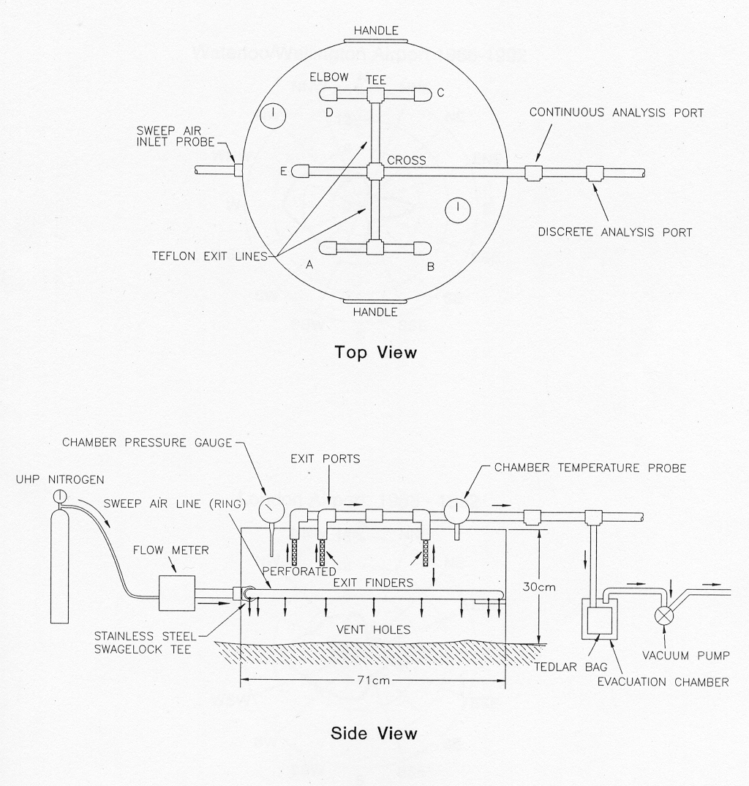

9.0 REFERENCES

1. European Committee for Standardization (CEN). Air Quality - Determination of Odour Concentration by Dynamic Olfactometry. EN 13725: Brussels, Belgium, 2003.
2. ORTECH Environmental, “Odour Assessment of Land-Applied Materials, Phase II”, June 24, 2005

NOTE: The Nutrient Management Tables document can be found at http://www.omafra.gov.on.ca.

