PUBLIC CONSULTATION FEEDBACK FORM
A Closer Look: Report on Home Inspector Qualifications in Ontario

Your views are very important to the Ministry of Consumer Services and we would like to hear what you think about the findings and recommendations put forward by home inspector panel. Your comments will be considered and will inform future government decisions.
You can make general comments or comment on specific issues. When commenting on a specific issue, it would help us if you tell us the recommendation number that is impacted.
Please input your comments below and email this competed form to the ministry at homeinspectors@ontario.ca. The closing date for receiving feedback is January 27, 2014.

About You  (please check the appropriate box)  ☐ Home inspector  ☐ Real estate practitioner  ☐ Organization/association  ☐Home inspection  ☐Real estate  ☐Other:  Insert here  ☐ Other: | Region  (please check the appropriate box)  ☐ 1. Central Ontario  ☐ 2. Eastern Ontario  ☐ 3. Greater Toronto Area  ☐ 4. Northern Ontario  ☐ 5. Southeastern Ontario  ☐ 6. Southwestern Ontario  ☐ 7. Western Ontario | 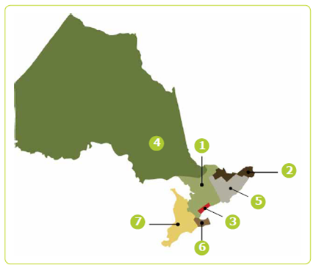

Report Sections
Regulation of home inspectors
Do you have any comments regarding recommendation #1
(insert comments)

Technical Standards for Home Inspectors
Do you have any comments regarding recommendations #2 to #4
(insert comments)

Professional Qualifications for Home Inspectors
Do you have any comments regarding recommendations #5 to #16
(insert comments)

Consumer Protection Requirements
Do you have any comments regarding recommendations #17 to #30
(insert comments)

Regulatory Governance for Ontario’s Home Inspection Industry
Do you have any comments regarding recommendations #31 to #35
(insert comments)

Other – general comments regarding regulating home inspectors
(insert comments)

Send Feedback to homeinspectors@ontario.ca by January 27, 2014

