 | BACKGROUNDER
Ministry of Community Safety and Correctional Services

Summary of Draft Regulation on Carding and Street Checks

Oct. 28, 2015

The province has posted two draft regulations for public input on the random and arbitrary collection of identifying information by police, referred to as carding or street checks, one new and one amended. The regulations will do two things:
- Expressly prohibit the random and arbitrary collection of identifying information by police; and
- Establish clear new rules for voluntary police-public interactions where identifying information is collected.

These rules will ensure that interactions are consistent, conducted without bias or discrimination, and done in a manner that promotes public confidence and keeps our communities safe. Once in force, the regulations will be mandatory for every police service in Ontario.

Summary of Proposal:

The proposed regulations reflect two key principles:
- Ontario takes the protection of human rights very seriously and has zero tolerance for racism or any form of discrimination based on skin colour, background, religion, sexual orientation or gender identity and gender expression; and
- Ontario stands opposed to arbitrary, random stops that do not have a clear policing purpose, and which are done solely for the purpose of collecting identifying information.

The regulatory changes being proposed include:

- Prohibitions on the Collection of Identifying Information:

The regulatory changes proposed would prohibit the collection of identifying information:
- Based solely on race; and
- Based on random or arbitrary stops (as defined below).

- Requirements for Voluntary Interactions:

Requesting Identifying Information

Police officers will be able to ask for identifying information only where they believe that the information would assist in:
- Gathering information about individuals known or reasonably suspected to be engaged in illegal activities
- Inquiring into suspicious activities for the purpose of detecting illegal activities.

The police officer’s detailed reasons (i.e., not a hunch or intuition) for requesting the information cannot be based on the fact that the individual:
- Is perceived to be within a particular racialized group
- Has declined to answer a question that they are not legally required to answer
- Wants to end the interaction with the police officer when they are legally entitled to do so.

In addition, a police officer’s request for identifying information cannot be solely based on the fact that the individual is in a high-crime neighbourhood.

Transparency and Individuals’ Rights

Police officers would be required to inform individuals:
- That they are not required to remain in the presence of the officer
- Why the information is being collected.

Limited circumstances where an officer would not be required to inform individuals include situations where it could:
- Compromise their ability to investigate a particular offence
- Result in the identification of a confidential informant
- Compromise the safety of an individual.

Police officers would be required to provide a document to individuals from whom they attempt to collect identifying information which, at a minimum, must include:
- The officer’s name and identification number (i.e. badge number)
- The date, time, location and reason for the collection
- Information about how the individual can contact the Independent Police Review Director (e.g., to file a complaint)
- How to access the information that was collected.
Exceptions

The proposed regulation would not apply in the following specific circumstances:
- The individual is legally required to provide the information to the officer (e.g., during a traffic stop)
- The individual is under arrest or being detained
- The officer is undercover
- The officer is investigating a particular offence
- The officer is executing a warrant, court order or other related duties
- The interaction involves attempting to collect information from someone involved in the administration of justice (e.g., Crown Attorney)
- The information is obtained during an informal or casual interaction and the officer has no intention, at the time of the request, to record the information (e.g., community policing and interactions at local events).

- Training, Data Management and Accountability Measures

Police services will be required to develop policies and procedures to implement the requirements of the proposed regulations.

The regulatory changes proposed would require mandatory training for police in areas such as bias awareness, discrimination and racism.

The regulation will require the Chief of Police to ensure that all police officers who will attempt to collect identifying information complete training every three years.

For every request for identifying information, police officers would be required to record details of the interaction.

Under the proposed changes, if identifying information is entered into a database it would have to be reviewed by the Chief of Police or his or her delegate within 30 days.

If it is determined that the police officer did not have a reason for requesting the identifying information that complied with the new rules, the identifying information would be restricted so that access to it could only be granted by the Chief of Police on a case-by-case basis.

To prevent unjustified stops, the regulatory changes proposed would prohibit Chiefs of Police from setting targets for officers based on the number of times an officer attempts to or collects an individual’s identifying information.

The proposed regulations would require Chiefs of Police to:
- Review his or her police force’s practices relating to the collection of identifying information on an annual basis
- Report on instances where identifying information was requested, including demographic statistics and plans for improvement if data analysis indicates bias on an annual basis

Police Services Boards and the Ministry (for the OPP) will be required to make these reports publicly available online.

- Rules for Officer Misconduct

Regulatory changes being proposed include an amendment to the Code of Conduct under the Police Services Act. If a police officer does not comply with the regulation and improperly attempts to, or does collect, identifying information in a manner that is not consistent with the proposed new rules, this could now be considered misconduct. In situations where misconduct has been found, the officer would be subject to disciplinary action under the Police Services Act.

Appendix: Engagement to Date

Over the summer the province conducted extensive consultations on the topic of street checks and carding

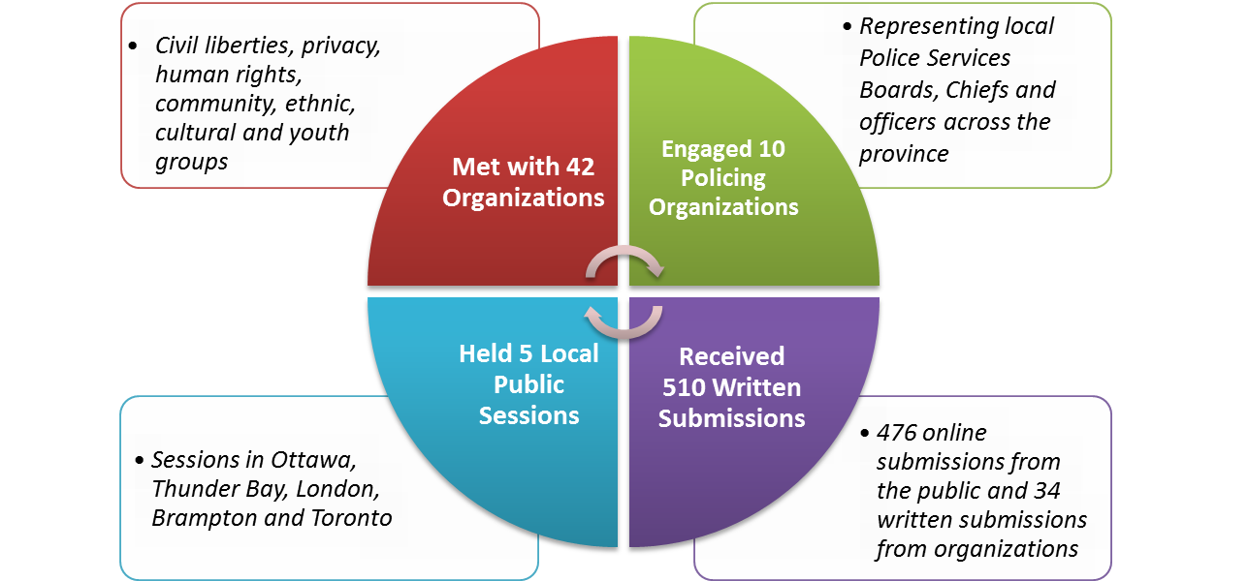

Lauren Callighen, Minister’s Office, 416-325-5982  Courtney Battistone, Communications, 416-325-0432 | ontario.ca/safety  Disponible en français

