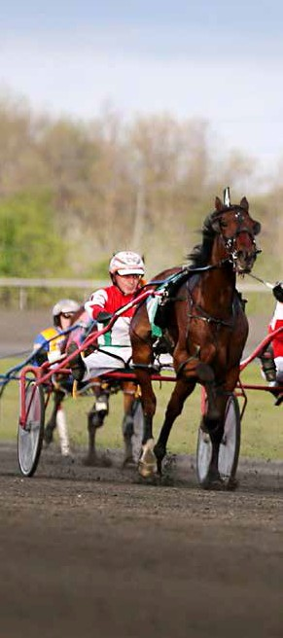
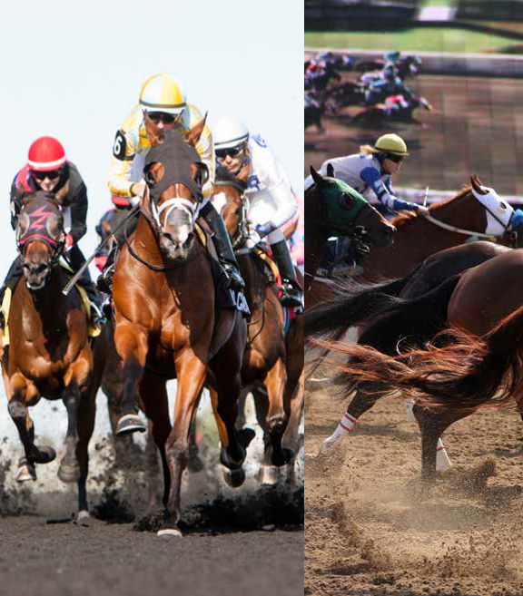

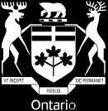

MOVING AHEAD: HORSE RACING REGULATION IN ONTARIO

AGCO CONSULTATION - JUNE 2016

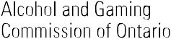

AGCO VISION

A leader in the alcohol, gaming and horse racing sectors through effective regulation and services that are fair, responsive and in the broader public interest.

AGCO MANDATE

To regulate the alcohol, gaming and horse racing sectors in accordance with the principles of honesty and integrity, and in the public interest.

Alcohol and Gaming Commission of Ontario

90 SHEPPARD AVE E - SUITE 200 TORONTO ON M2N 0A4
Fax: 416 326-8711
Tel: 416 326-8700 or 1 800 522-2876 toll free in Ontario

http://www.agco.on.ca

5032E (2016/06) © Queen’s Printer of Ontario, 2016 Disponible en Français

Table of Contents

MESSAGE FROM THE CEO 4
ABOUT THIS CONSULTATION 5
- INTEGRITY, SAFETY AND THE PUBLIC INTEREST IN
ONTARIO HORSE RACING 7
- REDUCINGTHE ADMINISTRATIVE BURDEN AND
REMOVING UNNECESSARY BARRIERS 11
- SUPPORTING ECONOMIC DEVELOPMENT AND
INDUSTRY INNOVATION 13
- SHIFTING TO A MODERN REGULATORY FRAMEWORK
FOR HORSE RACING IN ONTARIO 15

Message from the CEO

In April 2016, the Alcohol and Gaming Commission of Ontario assumed responsibility for the regulation of Ontario’s horse racing industry - a mandate that was previously delivered for over sixty years by the Ontario Racing Commission.

As a former Chief Executive Officer of the Ontario Racing Commission, I am genuinely excited to be “back in the saddle” and involved with horse racing in Ontario once again. The AGCO plays an important role as the provincial regulator of Ontario’s horse racing industry. We are responsible for developing, monitoring and enforcing a wide range of rules and procedures that ensure horse racing in Ontario is conducted fairly, honestly and in the public interest. In doing so, we strive to oversee horse racing in a manner that strikes an effective balance between the interests of tracks, horse people, equine athletes, and the betting public.

At the AGCO, we know that the horse racing industry plays an important role in communities across our province. It serves as a significant source of rural employment and contributes to Ontario’s rich
agricultural heritage. Horse racing also delivers entertainment for thousands of Ontarians, whether they enjoy racing as bettors or as spectators who visit the track for the love of the sport.

We are committed to doing our part. We want our approach to horse racing regulation to ensure fairness and safety in racing, while also serving to support a modern and thriving industry. That is why we are launching Moving Ahead: Horse Racing Regulation in Ontario, an AGCO-led initiative that is focused on identifying and moving forward with common sense changes to the regulatory rules and procedures that govern horse racing in Ontario.

Over the next several months, we will be consulting closely with individuals and organizations from across the province, beginning with the release of this consultation paper. We want to ensure that horse racing in Ontario meets the highest standards of fairness, integrity, and safety. At the same time, we want to
eliminate any unnecessary administrative burden and artificial barriers to growth and industry development.

We have our sights set on the future of horse racing regulation in Ontario. Ultimately, we are looking to create a regulatory approach that is simpler, more flexible, and better focused on the achievement of clear regulatory goals to ensure that the public interest in horse racing is enriched and protected.

This consultation is an opportunity for you to help shape the future of horse racing regulation in Ontario and I encourage you to actively participate. I want to thank you for taking the time to review this consultation paper and for providing us with your ideas and insights.

Sincerely,

Jean Major
Chief Executive Officer and Registrar of Alcohol, Gaming and Horse Racing

About this Consultation

This consultation paper is directed to the following businesses, individuals and associations in Ontario’s horse racing industry: racetracks, owners, drivers and jockeys, trainers, grooms, veterinarians, agents, tele-theatre locations, and any other individual or entity that requires a horse racing-related licence from the Alcohol and Gaming Commission of Ontario (AGCO). It is also directed to equine welfare organizations, breeders, horseplayers (i.e. bettors), industry associations, as well as businesses and government bodies whose mandate relates to Ontario’s horse racing industry.

This consultation is an opportunity for you to provide input and share ideas on the steps we can take together to ensure fairness, integrity, and safety in Ontario’s horse racing industry, while moving forward on opportunities to reduce the administrative burden on business and support the long-term sustainability of Ontario’s horse racing industry.

Throughout this paper, a number of specific ideas to change our approach to horse racing regulation are proposed and a series of questions are asked of you. Some of these ideas and questions will be applicable to you or your organization, while others may not. We encourage you to provide feedback where you can.

The issues that are discussed in this paper fall exclusively within the existing regulatory mandate of the AGCO as it relates to Ontario’s horse racing industry. As a result, this consultation does not directly consider changes to legislation or regulations and does not include issues relating to government funding or financial support programs for Ontario’s horse racing industry.

PROVIDING FEEDBACK

This document has been distributed directly to a number of individuals, businesses, associations, and government bodies. You can also access this document on the AGCO’s website at www.agco.on.ca and the Government of Ontario’s Consultations Directory at https://www.ontario.ca/page/consultations- directory. Please feel free to prepare your written submission by completing the fillable question and answer sections of this document or by preparing and submitting your own separate document.

You can provide your written submission directly to the AGCO by no later than August 26, 2016 in any of the following ways:
  - E-mail your written submission to the AGCO at the following dedicated e-mail address: connect@ agco.ca

  - Fax your written submission to the AGCO at the following number: (416) 326-8054

  - Mail your written submission to the attention of Hyla Zeifman, Senior Advisor of Strategic Engagement, at the following address:

Alcohol and Gaming Commission of Ontario
90 Sheppard Avenue East, Suite 200 Toronto, Ontario
M2N 0A4

Following the close of this written consultation period, the AGCO will hold a series of in-person roundtable discussions with interested stakeholders to further discuss proposals for reform and implementation details on a more in-depth basis.

Submissions received as part of this consultation will not be released publicly, except as may be required by the Freedom of Information and Protection of Privacy Act. Please note, however, that the AGCO intends to release to the public a detailed findings report which anonymously summarizes the advice and recommendations received over the course of this consultation period.

Integrity, Safety and the Public Interest in Ontario Horse Racing

ENSURING RACES ARE FAIR AND HONEST

In a highly competitive and global horse racing market, it is essential that races at Ontario’s licensed racetracks are consistently conducted in a fair and honest fashion. This means ensuring that Ontario has the right rules, procedures, technology, and expertise in place to prevent and detect instances where a race horse or race participant has an unfair advantage or disadvantage.

Ontario’s Rules of Racing currently include detailed rules aimed at maintaining the integrity of racing in the province, including such areas as:
  - equine drug testing and penalties;

  - race entry requirements for horses, drivers, and jockeys;

  - on-track conduct rules (e.g. pylon violations, interference, urging violation); and,

  - betting restrictions for industry participants.

In addition, regulatory staff – including licensing agents, judges and stewards, veterinarians, inspectors, and investigators – are assigned to every Ontario racetrack to make sure that the rules are followed and that appropriate action is taken when issues of non-compliance occur.

Looking ahead, the AGCO would like to know what additional steps can be taken to safeguard the integrity of horse racing in Ontario. For example, industry participants have told us that Ontario’s approach to equine drug testing could potentially be made more effective. We have also heard that there are opportunities to make better use of advanced video technology to support the officiating and review of races.

CONSULTATION QUESTIONS

Q1. What do you think are some of the main risks to the fairness and honesty of Ontario horse racing today?

Q2. What additional steps could the AGCO take to ensure that horse racing in Ontario is fair and honest?

PROTECTING THE HEALTH AND WELL-BEING OF RACE HORSES AND INDUSTRY PARTICIPANTS

The overarching priority of Ontario’s approach to the regulation of horse racing is the health and well-being of horse people and equine athletes. Over the years, Ontario has emerged as a global leader in horse racing health and safety standards by establishing detailed rules and procedures in such areas as:
  - the possession and use of equine medications;

  - out of competition testing;

  - pre-race veterinary examinations;

  - inappropriate on-track activity, such as urging violation;

  - human drug and alcohol programs; and,

  - race horse accident and death investigations.

At the AGCO, health and safety is one of our top priorities in the field of horse racing regulation - whether it be positive test investigations, officiating on-track interference and infractions, or ensuring safe track conditions. We know, however, that there are always opportunities to do better.

Looking ahead, the AGCO would like to hear from you about improvements to Ontario’s regulatory framework in order to better protect the health and well-being of both horse people and equine athletes. This may include, for example, suggestions regarding new or revised standards in such areas as positive drug tests, equipment requirements, track conditions, jockey weights, on-track misconduct, or racehorse retirement programs.

CONSULTATION QUESTIONS

Q3. What do you think are some of the main risks to the health and welfare of horse people and equine athletes in Ontario horse racing?

Q4. What specific measures should the AGCO consider to better protect the health and well-being of human and equine athletes in Ontario?

Reducing the Administrative Burden and Removing Unnecessary Barriers

Ontario’s horse racing industry makes an important and valuable contribution to the provincial economy. This is particularly the case in the dozens of communities across the province which host racetracks, training and breeding facilities, or other businesses that supply goods and services to the industry.

Running a business in the horse racing industry can be a costly, complex, and time-consuming experience, especially for those engaged in running the day-to-day business of a race track or managing the operations of a training or breeding facility.

At the AGCO, our goal is to provide effective regulatory oversight of horse racing in Ontario to make sure that the sport is conducted with honesty, integrity, and in the public interest. At the same time, we aim to ensure that our rules and procedures are not overly complex, do not impose too many time-consuming steps, and remain relevant in today’s horse racing environment.

We would like to hear from you about potential steps the AGCO can take to reduce the administrative burden and remove unnecessary barriers for racetracks, horse people, and others who participate in Ontario’s horse racing industry. Your suggestions may touch on such areas as:
  - simplifying Ontario’s licensing rules (for example, by reducing the need for participants to obtain multiple licences if they are involved in more than one of Standardbred, Thoroughbred, and Quarter Horse racing);

  - shifting to online service delivery, instead of today’s largely paper-based system;

  - limiting the right to appeal for certain low-level violations regarding on-track conduct (e.g. interference, pylon violations); or,

  - eliminating unnecessary and outdated rules regarding the day-to-day operations of a racetrack.

CONSULTATION QUESTIONS

Q5. What changes do you think the AGCO should implement to make it easier for you to meet your regulatory requirements?

Q6. What rules or procedures do you think are unnecessary and should be either fixed or eliminated?

Supporting Economic Development and Industry Innovation

The long-term sustainability and success of Ontario’s horse racing industry relies heavily on the ability of racetracks to offer a high-quality racing product that attracts a substantial wagering pool from multiple betting channels (i.e. on-site, inter-track, off-site and online wagering).

As Ontario’s horse racing regulatory authority, the AGCO can play a role in supporting economic development and innovation in Ontario’s horse racing industry. We believe that regulatory rules and procedures should not serve as an unnecessary obstacle to the success of Ontario’s horse racing industry. Moreover, regulatory tools can, in appropriate circumstances, be used to advance the commercial success of horse racing in Ontario as a whole, including through the use of advanced technology.

In recent years, new and innovative regulatory measures have been adopted in several global horse racing jurisdictions aimed at increasing the fan experience, encouraging investment in horse ownership, and addressing the loss of industry investment and wagering activity to offshore and unregulated gambling websites. For example:

  - the State of New York has recently implemented measures to improve the fan experience by increasing the transparency of steward decision-making at the track and on telecasts, including post-race disclosure of ruling information;

  - several regulatory agencies have established rules to encourage newcomers to horse ownership, most notably through “syndicate” or “fractional” ownership models; and,

  - authorities in the United Kingdom, New Zealand and several U.S. states have taken a proactive approach to combat the negative impact on domestic horse racing industries of offshore and unregulated online gambling sites.

CONSULTATION QUESTIONS

Q7. What do you believe are the most important factors to ensuring the long-term economic sustainability of Ontario’s horse racing industry?

Q8. What specific measures should the AGCO pursue to support the commercial success of horse racing in Ontario?

Shifting to a Modern Regulatory Framework for Horse Racing in Ontario

Over the past several decades, Ontario’s regulatory framework for horse racing – centred on the Rules of Thoroughbred Racing (Quarter Horse Addendum) (2016) and Rules of Standardbred Racing (2016) – has evolved and expanded. The subjects covered in the Rules include such broad and diverse subjects as licensing, race entries and scratches, track safety and security, equine and human drug testing, on-track conduct, race protests, track conditions, and horse ownership – among many other matters.

Looking ahead to the future of horse racing regulation, we are eager to find new ways and opportunities to shift Ontario’s approach to horse racing regulation. Our ultimate goal is to have a horse racing regulatory framework that is simpler, more flexible, and better focused on the mitigation of regulatory risks and the achievement of clear regulatory outcomes

This means finding ways to eliminate unnecessary rules to provide greater flexibility to licensees. It also means taking a close look at our processes, and the regulatory roles and responsibilities performed by the AGCO in order to determine whether there are certain areas where we should be doing more or less.

In recent years, the AGCO has overhauled its approach to gaming regulation by establishing a set of modern regulatory standards. In the beverage alcohol sector, the AGCO has consulted extensively with stakeholders in recent years in order to move ahead with a series of policy changes that remove barriers to new investment and innovation. We are now looking to hear from you about how the AGCO can shift to a more modern regulatory framework for Ontario’s horse racing industry.

CONSULTATION QUESTIONS

Q9. In your view, what are some of the main sections of Ontario’s Rules of Racing that are currently too prescriptive and/or outdated?

Q10. What areas of horse racing regulation, if any, do you think the AGCO should no longer be involved in? Are there any areas that you think the AGCO should pay more attention to?

CONSULTATION QUESTIONS

Q11. Do you have any additional insights or advice on ways that we can strengthen horse racing regulation in Ontario and our current processes?

